VisCanvas Demo Tutorial Documentation

## Opening Data Editor

The standard procedure prior to running the program for the first time is to modify the data to ensure it works with VisCanvas. For this example, the IRIS dataset is used to illustrate the concepts of the program. However, the pure IRIS dataset is not setup to run on VisCanvas so we will start by editing the data.

Upon opening VisCanvas click the “file” menu in the top left of the window

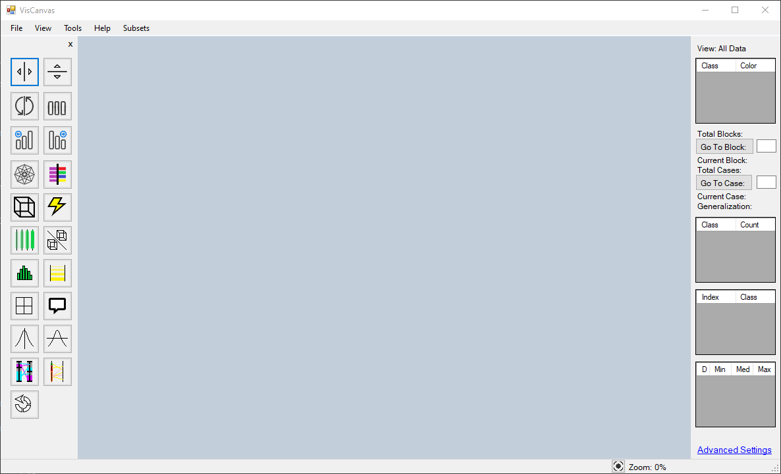

Click the “Edit Data” option in the “file” drop down menu

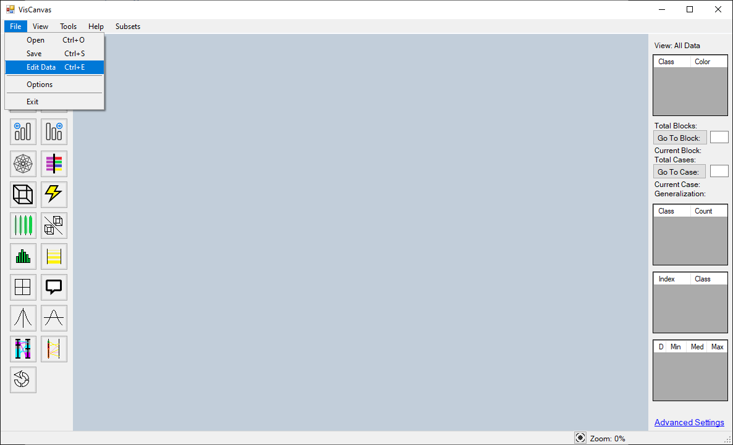

This will open the VisCanvas Data Editor

## Opening a File in the Data Editor

Click the “file” menu in the top left of the window

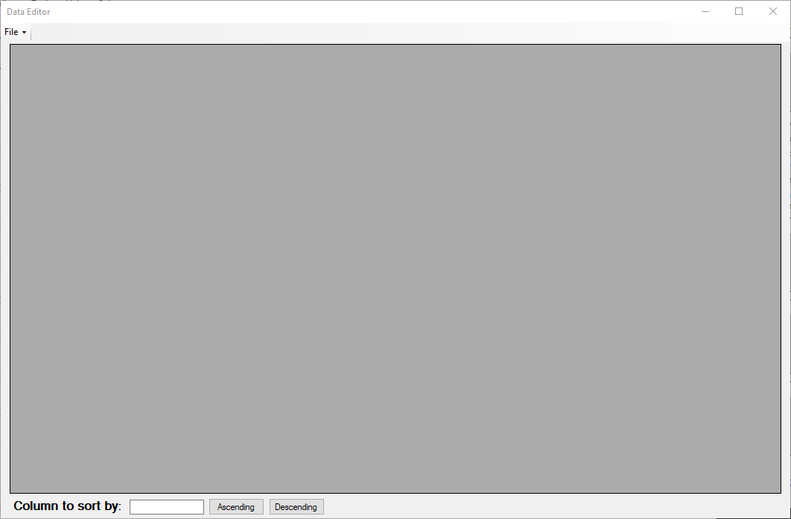

Click the “open” option in the “file” dropdown menu

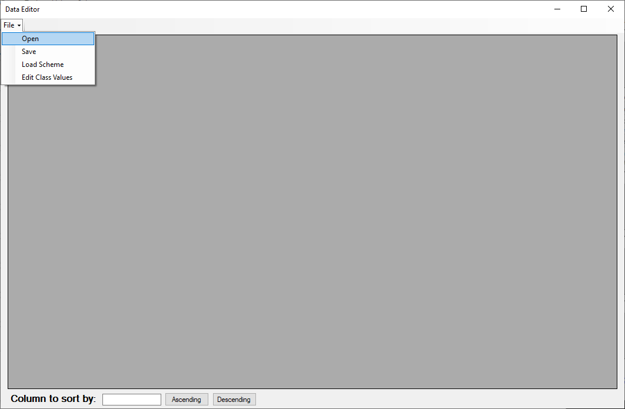

Select the file you wish to edit in the Window’s file explorer window that opens. In this case open the “iris.data.csv” file.

## Editing Class Values in the Data Editor

Once the file is open, click “File” in the top left and then select “Edit Class Values” from the drop-down menu.

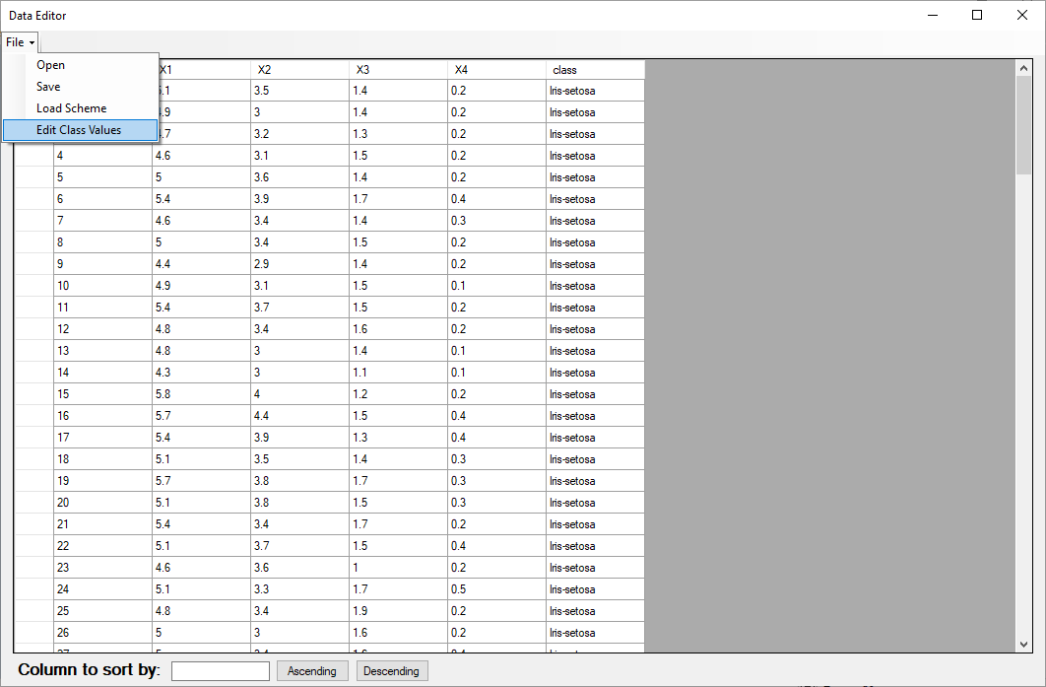

This will open the following window *NOTE: Do not close this window before making your changes. If you do not want to make changes, simply type the same class name into the “Value” column*:

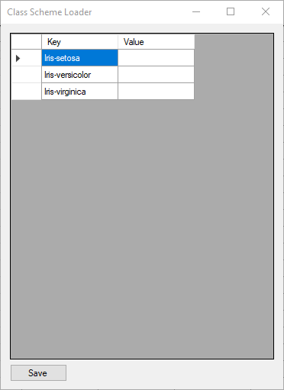

This window allows the user to replace the class value with ease. VisCanvas requires that all data be converted to numerical values, so we will change the class values to 0, 1, and 2 from their text forms:

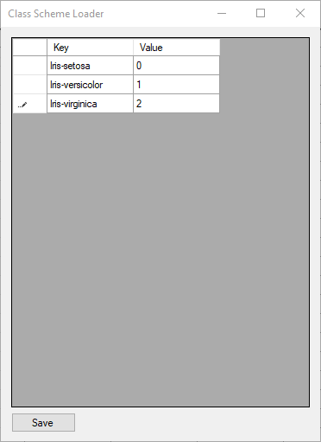

Once you have entered the values like above, click save:



Once this is complete, the window will close and all the class values will be replaced with the new values. Now we must simply save the new data document by clicking “File” and selecting “Save” in the drop-down menu:

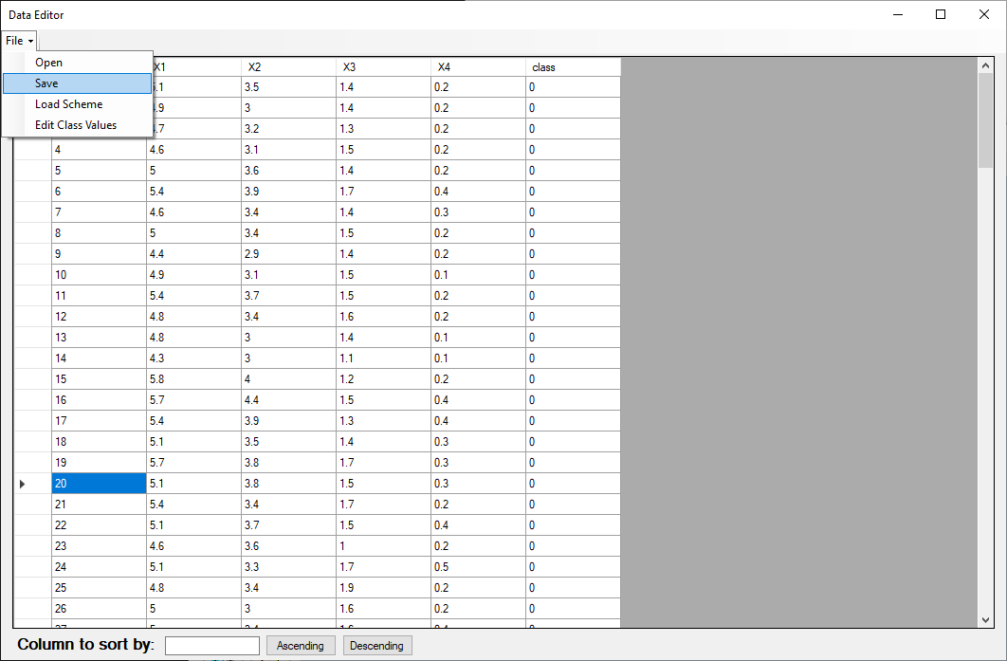

This will open Windows File Explorer where you will save the document as “**iris.data.form.csv**” so that we can use it later.

## Opening a file for visualization

Upon opening VisCanvas click the “file” menu in the top left of the window



Click the “Open” option in the “File” drop down menu

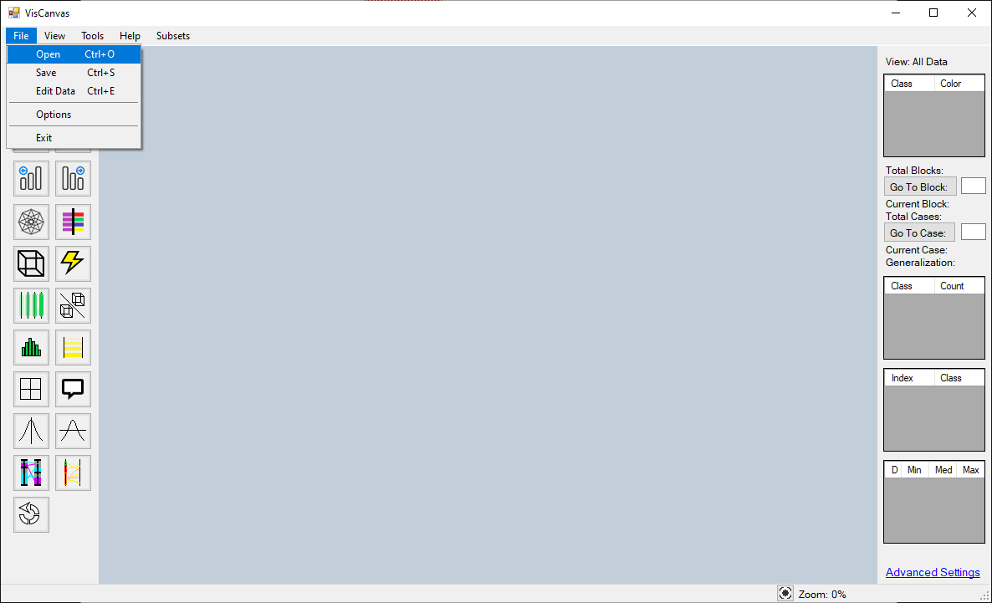

Select the file you wish to visualize in the Window’s file explorer window that opens. In this instance open the “iris.data.form.csv” file that you saved earlier to load the edited Iris Dataset into VisCanvas.

## Hypercube Creation

With an initial visualization created, creating Hypercube clusters can help the user understand the trends of the data better.

Once the data has loaded into VisCanvas, creating Hypercube clusters is very easy. To auto-generate hypercube clusters click the icon with the yellow lightning bolt:

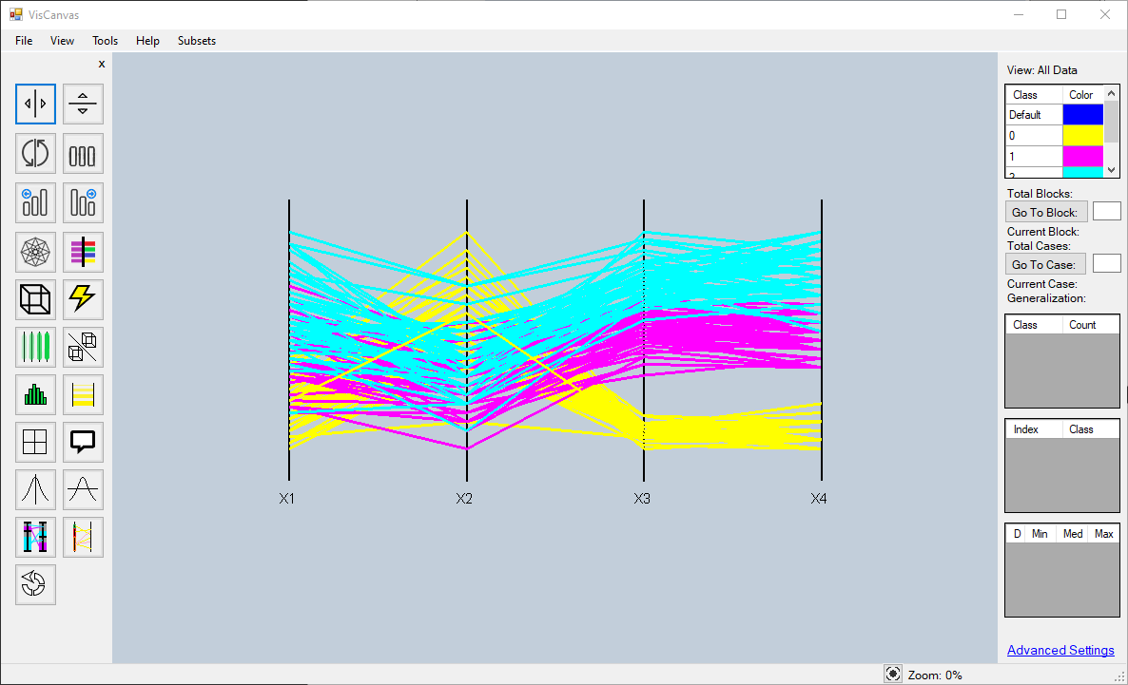

With the hypercubes generated, any of these buttons will change the view for the user to help make sense of the data. To go back to the original hypercube cluster visualization, simply click the same button again which changed the view:

## Dominant Nominal Sets

Dominant Nominal Sets is another visualization method that VisCanvas offers. To show the dominant nominal set visualization click the button with two bars which show purple and blue on them:

Once clicked, the window will change to look like the following:

Once on the Dominant Nominal Set Window, the user can make a view modifications to the visualization:

### Horizontal Shift

Clicking the button with a vertical line with an arrow on either side allows the user to move the dimensions along the horizontal axis:

Once clicked, the lines will disappear and the user can drag the individual attribute bars right or left to change their order in the visualization. In the image below I moved X1 from the left to the right so that it is after X4. Once it is in the position you want it, click the same button to bring back the lines in the visualization:

### Vertical Shift

Clicking the button with a horizontal line with an arrow on either side allows the user to move the dimensions along the horizontal axis:

Once clicked, the lines will disappear and the user can drag the individual attribute bars up or down to change their height in the visualization. In the image below I moved X1 up. Once everything is in the position you want it, click the same button to bring back the lines in the visualization:

